Brewer’s Goldendoodles
Feeding Program

Your puppy has been eating

Purina Pro Plan Lamb & Rice Puppy

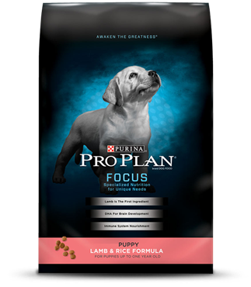
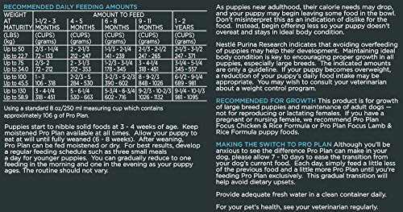

Finding a good puppy/dog food is vital to having a happy and healthy doodle. When looking for a food be sure to stay away from corn, wheat and by-products just to name a few. The website below has a wide selection of dog food ratings and can be very helpful in looking for a new food.
https://www.chewy.com/purina-pro-plan-focus-puppy-lamb-rice/dp/52422
https://www.proplan.com/dogs/products/focus-puppy-lamb-rice-formula
Dog Food Advisor Website
Usually by 8 months old, the girls can maintain on 3-3.5 cups a day while the boys may continue to need a cup or so more for several more months. What you want to see is a weight gain of approximately 2 lbs a week. This should be easy to monitor as you will be going to the vet several times early on. While you don’t want them too heavy, you do want to maintain a weight that will keep their bone mass through the growing process.
Allow your puppy a quiet place to eat. Do not distract them while they are trying to eat. I recommend feeding three times a day, if possible. If it is not possible, don’t worry, puppies will adapt to your schedule. The daily amount of food can be split into three portions. When you are home make sure that plenty of water is available to your puppy throughout the day. Once the puppy reaches 4 months old, you can switch to feeding twice a day and continue this throughout their lives. By 6 months old you can switch over to an adult formula food.

You should not have to give your dog any supplements if you are feeding a quality, well rounded food. Remember to read the ingredients in your dogs’ food and avoid corn, wheat and by-products. Treats are fine in moderation. You can break them into small pieces for training or you can try carrots or apples instead.

Be careful to use common sense and moderation when it comes to exercise. Jumping, jogging, field training, etc. are considered forced exercise and can be very hard on developing bones and joints. These types of movements should be avoided until your puppy reaches the age of 18 months old. They do need regular exercise to support proper muscle condition to support their bones. A good rule of thumb is 5 minutes of walking for each month in age.
If your puppy needs to be crated for longer than 3-4 hours while you are away, try enclosing a crate in an exercise pen so your puppy will have a place to sleep and a place to potty. This set up is only to be used short term as puppies will learn to climb pretty quickly. Using a baby gate or two in a laundry/mud room can also work well in the short term. Fleece pads are safest for crates because they don’t have threads that can strangle a puppy’s bowels. Be sure to remove your puppy’s collar before going into the crate. Do not use cedar or pine stuffed bedding as it can cause allergic reactions. You may also want to avoid using anything with a pine derivative for cleaning (Carpet Fresh, Lysol, Murphy’s Oil Soap, etc.) Wash their crates with a mild bleach solution when necessary.
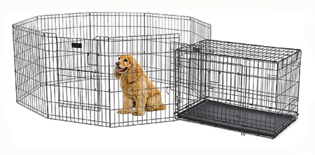

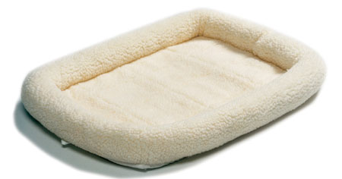
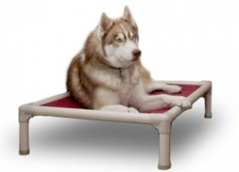

http://kuranda.com/
Chew proof dog beds!
Kuranda has an awesome selection of beds for your doodle
Bringing Puppy Home

Young puppies are very resilient and should adjust well to their new environment. There will likely be some crying and whining, that’s unavoidable sometimes. There are some things that you can do to help the transition from our home to yours.
- Be a comforting presence her first few nights, but be careful not to establish a pattern of dependency. She will likely cry or whine due to missing her siblings and mom. Do not scold your puppy when she may already be feeling uncomfortable in her new environment. On the flip side, catering to her every whim will only teach her that you come when she makes noise.
- Establish a safe, warm and comfortable sleeping area for the new puppy. You can place her crate in your room/a childs room/or basically any room where she will feel comfortable. You can also play a radio/TV in the background to help soothe. We highly recommend crate training your new puppy.
- Place a cloth or soft toy from her former home in the crate with her. The familiar smell will remind her of mother and offer comfort. Leave on a soft light so she can see his surroundings.
- Play with her quietly and gently. Don't flood her with attention and activity. If she looks like she wants to sleep, leave her alone. Puppies need lots of sleep.
- A puppy must learn to inhibit their bite before they are 4 months old. Normally, they would learn this from their mother, their littermates and other members of the pack. But, because we take them away from this environment before this learning is completed, we must take over the training for biting.
- By allowing your puppy to socialize with other puppies and socialized dogs they can pick up where they left off. Puppies need to roll, tumble and play with each other. When they play, they bite each other everywhere and anywhere. This is where they learn to inhibit their biting. This is where they learn to control themselves.
- If they are too rough or rambunctious, they will find out because of how the other dogs and puppies react and interact with them. This is something that happens naturally and it is something we cannot accomplish. It can only be learned from trial and error. There is nothing you can say or do to educate them in this realm. They must learn from their own experience with another dog or puppy.
- Another major advantage of dog to dog socialization besides the fact that it will help your dog to grow up not being fearful of other dogs is that they can vent their energy in an acceptable manner. Puppies that have other puppies to play with do not need to treat you like littermates. So the amount of play biting on you and your family should dramatically decrease. A puppy that does not play with another puppy or dog is generally much more hyperactive and destructive in the home as well.

